In this lecture, The fourth part of the first module was covered. Which is “Operators”

There are various types of operators in python. Those are,

* Arithmetic Operators
* Comparison Operators
* Python Assignment Operators
* Logical Operators or Bitwise Operators
* Membership Operators
* Identity Operators
* Operator precedence

In this module, We will learn few types of them.

1. **Arithmetic operators**

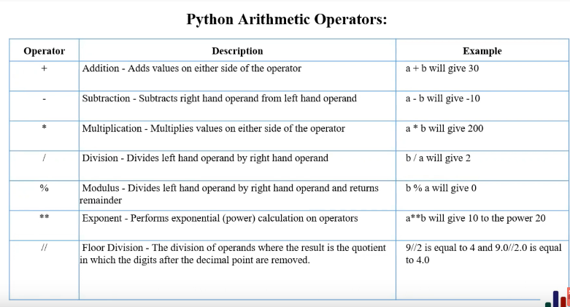

These types of operators are used to perform various arithmetic calculations on numerical (Integer/ Float) variables such as addition, subtraction, multiplication, division etc.

* + = sums the variables with one another
* - = subtracts the variables from one another
* * = multiplies the variables with one another
* / = divides the variables with one another
* % = gives the remainder after the division of the variables with one another
* ** = exponent or serves as the power of the base of the variables.
* // = gives a round figure of the resultant of the division.

**2. Comparison operators**

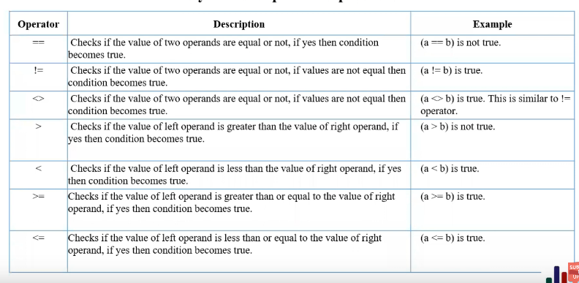

These types of operators are used to compare variables with one another

* == = checks if the variables are equal
* != = checks if the variables are not equal
* <> = Same as the previous one (!=), checks if the variables are not equal.
* > = checks if one of the variables are greater than the other
* < = checks if one of the variables are less than the other
* >= =checks if one of the variables are greater or equal than the other
* <= =checks if one of the variables are less or equal than the other

**3. Python assignment operators**

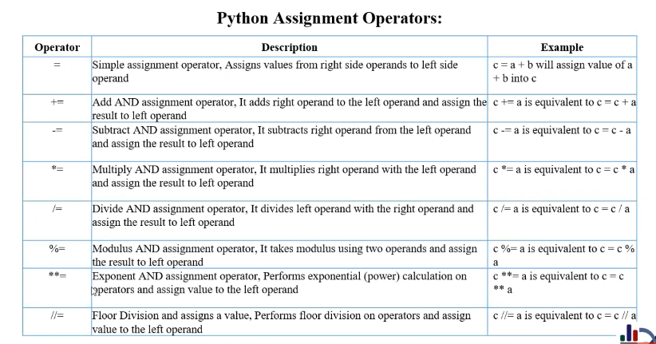

These types of operators are used to assign values to variables

* = = Assigns a value to a variable
* += = Sums and assigns right variables value to the left variable
* -= = Subtracts and assigns right variables value to the left variable
* *= = Multiplies and assigns right variables value to the left variable
* /= = Divides and assigns right variables value to the left variable
* %= = Takes modulus of two variables and assigns right variables value to the left variable
* **= = Does exponent calculation on variables and assigns it to another variable
* //= = Does floor division on variables and assigns it to another variable

**4. Bitwise operation**

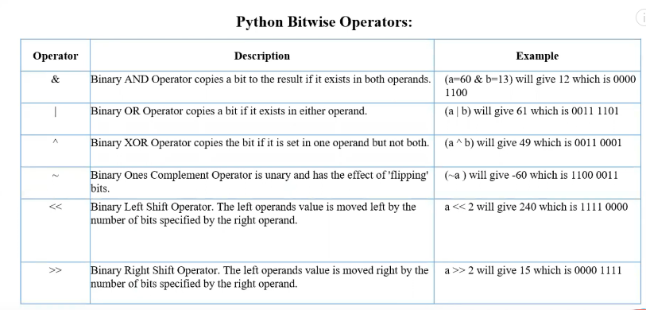

These operators do bitwise or binary calculations on numerical values assigned to variables.

* & = Does AND operation between two variable
* | = Does OR operation between two variable
* ^ = Does XOR operation between two variable
* ~ = Does ONE’S COMPLEMENT operation between two variable
* << = Does LEFT SHIFT operation between two variable
* >> = Does RIGHT SHIFT operation between two variable

**5. Logical operation**

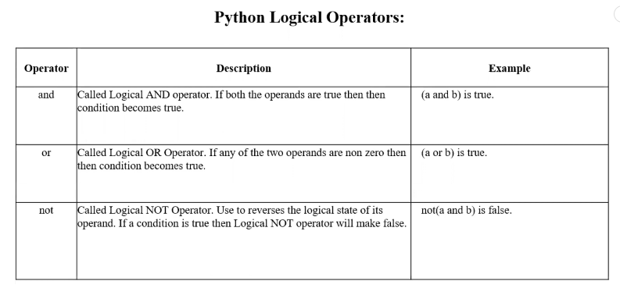

These operators check if one or more conditions are true or not at the same time.

* AND = Checks if both the conditions are true or not
* OR = Checks if only one of the conditions are true or not
* NOT = Checks if a condition is false or not

**6. Membership operation**

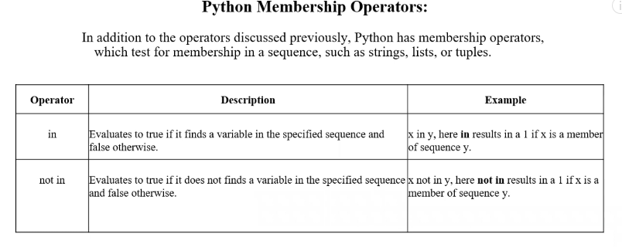

These operators check if something specific is inside something else or not.

* IN = CHecks if something specific is inside something else
* NOT IN = CHecks if something specific is not inside something else

**6. Identity operation**

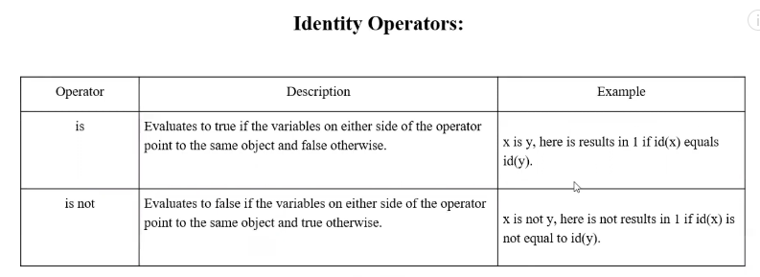

These operators check if two variables are identical or not.

* IN = Checks if two variables are identical
* NOT IN = Checks if two variables are not identical

There lies a precedence or hierarchical relation between these operators. Which will be executed before which one and all. This relation is given below.

